William Te; Kyana Bowers

Implementation Plan

Navy Food Security

Table of Contents

Introduction 2

Purpose 2

Assumptions and Constraints 2

Constraints 2

Assumptions 2

Major Tasks 2

Implementation Schedule 3

Implementation Support 3

Software 3

Hardware 3

Documentation 3

Version Control 4

Acceptance Criteria 4

Project Implementation Plan Approval 4

# Introduction

## Purpose

This plan outlines the implementation of the Navy Food Security Project (NFS). This project requires a website as well as a mobile application with a QR code scanner and reader, as well as a database which will store food orders and associated information. We are required to create.

## Assumptions and Constraints

### Constraints

* **Skills:** One team member does not have any experience creating a mobile app. To resolve this, that member will need to undergo extra training outside of work hours to develop their skills.
* **Software:** On our own devices, we will need to install a range of programs to allow us to do our project This may require hardware that we do not have.  
  These include:
  + The Visual Studio IDE and Xamarin.Forms component for the mobile app portion of the project.
  + PHPStorm and the Laravel framework for the website development portion of the project.
* **Schedule:** As well as this project, members also have work and the deadline of 17 weeks total to get the project to a Minimum Viable Product. 7 weeks of this is dedicated to documentation, which leaves 10 weeks to get the mobile app completed.

### Assumptions

* **Client Contact:** Our client is a member of the Australian Defence Force; as a result, they are unable to be contacted for long periods of time.This means we may need to make major decisions on their behalf, then in a future meeting, revise these decisions and change the project.
* **Deployment Platform:** As the client has not specified the website and API hosting solution, we will be using Heroku, as it is secure, and we have experience using this PaaS.

# Major Tasks

Major Tasks for this project include:

* Write documentation
* Get documentation approved by team members
* Show documentation to client
* Database setup
* API deployment
* Environment setup
* Begin creation of application, using version control to back up the project.
* Begin prototyping components of the project.
* Use Testing Plan to confirm these prototypes work as intended.
* Add prototypes to main project.
* Use testing plan to confirm main project works as intended
* Present project to supervisor for confirmation
* Present project to client.

# Implementation Schedule

Implementation Schedule Gantt chart can be found here:

<https://trello.com/b/8OE0uZKM/implementation-plan-gantt-chart>

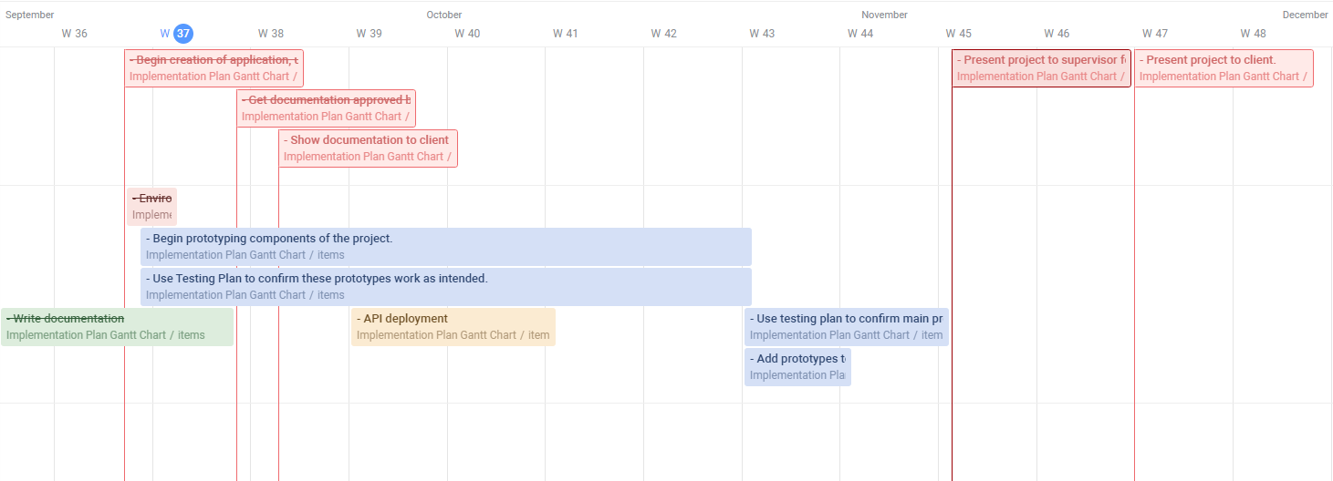

# Implementation Support

## Software

Software required for the creation of this application include:

* Navy specified operating system
* Visual Studio IDE for programming and performance monitoring
* Xamarin.Forms Framework for mobile app development
* MySQL Database Management System

## Hardware

Hardware required for the creation of this application include:

* PC with internet access for API
* Android tablet for testing
* RF scanning gun

# Documentation

Documentation that accompanies this project includes:

* Scope Document
* Requirements Document
* Mobile Application Wireframes
* Test Plan
* Implementation Plan
* MoSCoW Table

# Version Control

Version Control will be utilised using GitHub for documentation and application development. It will be kept up to date with different forks for each member. This will ensure conflicts are minimised and each member’s implemented components work as expected without jeopardising the rest of the project.

# Acceptance Criteria

All documentation will be peer reviewed by other team members, then by the project supervisors before being handed to the client. In terms of project tasks and components, they will be first created as separated prototypes. These prototypes will be tested extensively for every outcome, and if they succeed in every scenario, will they be implemented into the main project.

# Project Implementation Plan Approval

**The undersigned acknowledge that they have reviewed the Navy Food Security Implementation Plan and agree with the information presented within this document. Changes to this Project Implementation Plan will be coordinated with, and approved by, the undersigned, or their designated representatives.**

|  |  |  |
| --- | --- | --- |
| **SIGNATURE** | **PRINTED NAME** | **DATE** |
|  |  |  |
| **TITLE** | **ROLE** | |
|  |  | |